2026, YEAR OF MATH
A cross-party, bicameral resolution has been introduced in the U.S. Congress to designate 2026 as the “Year of Math.” Lawmakers from both parties emphasize that strong math education is essential for preparing students for a technologically advanced workforce and for maintaining national competitiveness.
Supporters highlight that mathematics underpins major technological innovations—from artificial intelligence to advanced manufacturing and national defense. With the International Congress of Mathematics set to take place in the United States in 2026, they see this as an ideal moment to inspire future innovators. Representatives from the American Mathematical Society welcomed the bipartisan support, noting the close connection between mathematical research and technological progress.
The resolution is as follows:
“The House of Representatives
(1) expresses support for the declaration of a "Year of Math" in the United States;
(2) celebrates the United States being selected as host of the International Congress of Mathematicians 2026 and using this platform to increase the visibility of mathematical sciences as fields of study and to communicate the myriad benefits of education in mathematics and statistics;
(3) recognizes that mathematics underpins all of the STEM (science, technology, engineering, and mathematics) disciplines, which are critical to the national security and economic prosperity of the United States; and
(4) celebrates the role that mathematics and statistics play in the everyday lives of all people of the United States, including in technology, news, games, literature, and music.”
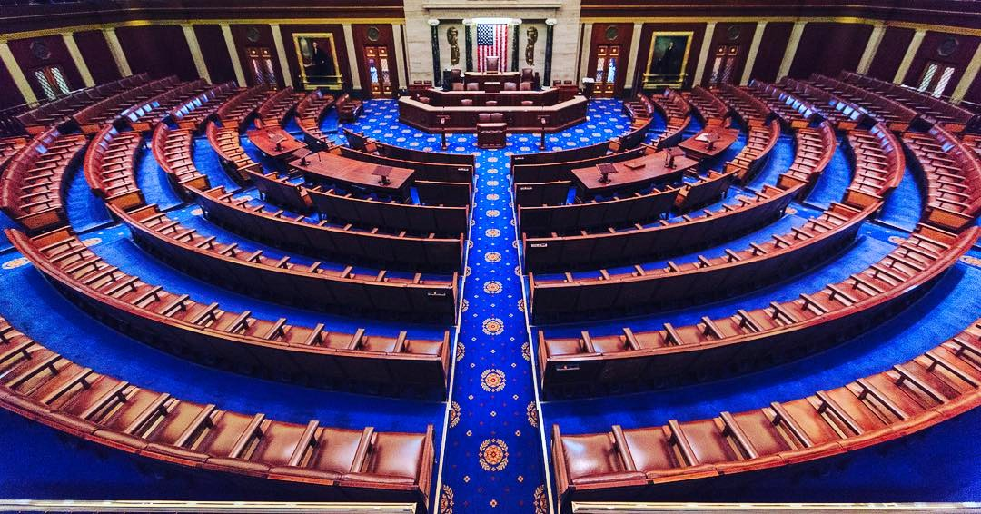

2026 ABEL PRIZE
German mathematician Gerd Faltings has been awarded the 2026 Abel Prize, often regarded as the “Nobel Prize of Mathematics,” in recognition of a career that has profoundly transformed arithmetic geometry.
The Norwegian Academy of Science and Letters highlighted his decisive contributions to this field, which lies at the intersection of number theory and geometry, as well as his groundbreaking advances in the study of Diophantine equations.
Faltings, who received the Fields Medal in 1986, gained international prominence at a young age after proving Mordell’s conjecture, a long-standing open problem that later became foundational for major developments such as the proof of Fermat’s Last Theorem. But, as stated in his profile of the European Academy he researches “whatever he finds interesting”. His book “Degeneration of Abelian Varieties”, written with Ching-Li Chai, has been studied by a large number of students and researchers all over the world.
With this award, the committee emphasizes the enormous influence of his work on modern mathematics.


2026 JOHN VON NEUMANN PRIZE
Dr. Mark Newman of the University of Michigan has been awarded the 2026 John von Neumann Prize, the highest honor of SIAM, for his influential contributions to the theory and algorithms of network science and their applications to real-world systems. His work has advanced the understanding of network structure and produced widely used methods for analyzing networks. He will receive the prize and deliver the lecture at the 2026 SIAM Annual Meeting in Cleveland.

Newman’s career includes studies at Oxford, postdoctoral work at Cornell, and positions at the Santa Fe Institute and the University of Michigan. He is recognized for foundational research in areas such as random graph models, community detection, mixing patterns, stochastic block models, message passing, small-world networks, and network epidemiology, with applications across many scientific fields.

He has received numerous honors, including fellowships from the Royal Society, APS, and AAAS, as well as major prizes such as the ISI Lagrange Prize and the APS Leo P. Kadanoff Prize. The John von Neumann Prize, established in 1959, honors exceptional contributions to applied mathematics.
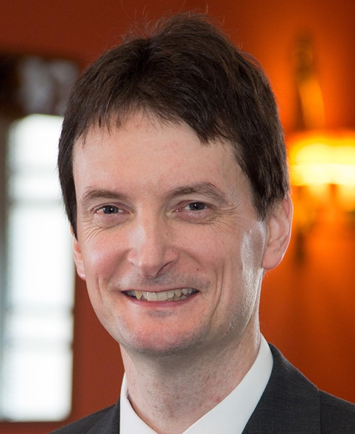

FRANCESCO CALOGERO MEMORIAL
Professor Francesco Calogero died on January 30th in Rome, Italy. Francesco Calogero was a highly influential physicist and a long-time professor at the Department of Physics at Sapienza University of Rome. Throughout his academic career, he became a leading authority in the study of nonlinear phenomena, making foundational contributions to integrable models and nonlinear equations. His work earned him significant recognition both in Italy and internationally. Among his most notable distinctions were the 2019 Dannie Heineman Prize for Mathematical Physics—awarded for his deep and original contributions to exactly solvable models and many-body problems—and the 2019 President of the Republic Prize from the Accademia dei Lincei, which honored his groundbreaking research on exact solutions and integrable many-body systems.
Calogero’s impact, however, extended far beyond the scientific community. He played a major international role in promoting arms control, nuclear disarmament, and peaceful conflict resolution. From 1989 to 1997, he served as Secretary General of the Pugwash Conferences on Science and World Affairs, during which he organized more than seventy international meetings aimed at reducing global tensions and fostering dialogue between nations. His leadership coincided with the period in which Pugwash was awarded the 1995 Nobel Peace Prize, recognizing the organization’s efforts to diminish the role of nuclear weapons in international politics.


